**GW-Basic Programs**

**Practical: 1- Write a Program to Print even numbers from 1 to 40.**

**Program:**

10       CLS

20      FOR B = 2 TO 40 STEP 2

      30      PRINT B

      40      NEXT  B

      50      END

**Algorithm**

Step 1  START

Step 2  STORAGE    B=2

Step 3  DECISION    IS B<= 40 IF

NOT THEN GO TO STEP 7

Step 4  COMPUTE    B=B+2

Step 5   PRINT

STEP 6  GOTO STEP 3

Step 7 END

[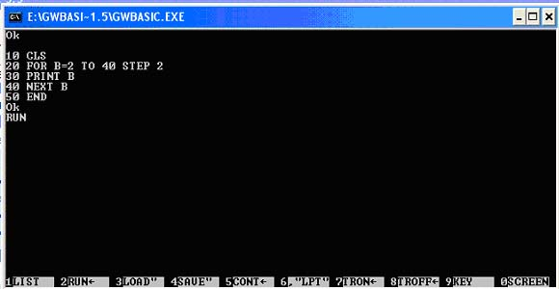](http://4.bp.blogspot.com/-3VyKEmGO42M/TyJz2hpQ7uI/AAAAAAAAADc/uplNt0J08aE/s1600/p1.jpg)

[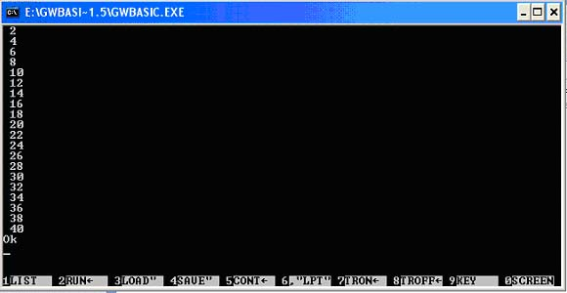](http://2.bp.blogspot.com/-bIaKQ2sO0y8/TyJ0LBUugvI/AAAAAAAAADk/KQEoS7suJzc/s1600/p11.jpg)

**Algorithm**

Step 1  START

Step 2  INPUT      L , W

Step 3  COMPUTE   AREA= L * W

Step 4    PRINT   AREA

Step 5  END

**Practical: 11: Write a program that can calculate the perimeter of the rectangular**.

**Program:**

10    CLS

20     INPUT “Length …=”;L

30     INPUT  “Width …=”; W

40     PERIMETER=  2* ( L+W)

50     PRINT “ PERIMETER….. =”; PERIMETER

60     END

**Algorithm**

Step 1  START

Step 2  INPUT      L , W

Step 3  COMPUTE   PERIMETER = 2* ( L+W)

Step 4    PRINT   PERIMETER

Step 5  END

**Practical: 12: Write a program that can calculate the square and cube of any number.**

**Program:**

10    CLS

20     INPUT “ Enter any No..…=”; N

30     Sq = N*N

40     Cub= N^3

50     PRINT “ Square….. =”; Sq

60     PRINT “ Cube….. =”; Cub

70      END

**Algorithm**

Step 1  START

Step 2  INPUT      N

Step 3  COMPUTE   Sq = N*N

Step 4 COMPUTE   Cub = N^3

 Step5  PRINT   Sq ,Cub

Ste

**Practical: 13: Write a program that can convert temperature from Centigrade to Fahrenheit**

**Program:**

10    CLS

20     INPUT “ Temperature in Centigrade :=”; C

30     F = 9/5* C+32

40     PRINT “Temperature in Fahrenheit =”; F

50     END

**Algorithm**

Step 1  START

Step 2  INPUT      C

Step 3  COMPUTE    F = 9/5* C+32

Step 4  PRINT        F

Step 5  END

**Practical: 14:** **Write a program that can convert temperature from Fahrenheit to Centigrade**

**Program:**

10    CLS

20     INPUT “ Temperature in  Fahrenheit  :=”; F

30     C = 5/9* ( F-32)

40     PRINT “Temperature in Centigrade  =”; C

50     END

**Algorithm**

Step 1  START

Step 2  INPUT      F

Step 3  COMPUTE    C = 5/9* ( F-32)

Step 4  PRINT        C

Step 5  END

**Practical: 15:  Write a program that can draw a Triangle.**

**Program:**

10    CLS

20     SCREEN 2

30     LINE  (110,50)- (160,100)

40     LINE  (60,100)- (160,100)

50     LINE  (110,50)- (60,100)

60     END

**Algorithm**

Step 1      START

Step 2       PRINT SCREEN 2

Step 3       OUTPUT       LINE (110, 50) - (160,100)

                                 LINE (60,100) - (160,100)

                                 LINE (110, 50) - (60,100)

Step 4            END

**Practical: 16:  Write a program that can draw a Rectangle.**

**Program:**

10    CLS

20     SCREEN 2

30     LINE  (70,80)- (190,170),,B

40        END

**Algorithm**

Step 1      START

Step 2       PRINT SCREEN 2

Step 3       OUTPUT       LINE (70, 80) - (190,170),, B

Step 4       END

**Practical: 17: Write a program that can add 15+ 30+20+325.**

**Program:**

10    CLS

20     READ A,B,C,D

30     SUM= A+B+C+D

40      PRINT “SUM OF 15,30,20 AND 325 IS…=”; SUM

50      DATA 15,30,20,325

60       END

**Algorithm**

Step 1      START

Step 2       STORAGE       A=1

Step 3       DECISION      IS A <=4, IF NOT THEN GOTO STEP 8

Step 4       COMPUTE      A=A+1

 Step 5       COMPUTE     SUM = SUM +5^A

 Step 6        PRINT   5^A, SUM

 Step 7       GOTO STEP 3

Step  8        END

**Practical: 18: Write a program that can print all odd numbers from 1 to 100**.

**Program:**

10    CLS

20    FOR N = 1 TO 100 STEP 2

30    PRINT       N

40     NEXT   N

50      END

**Algorithm**

Step 1      START

Step 2       STORAGE       N=1

Step 3       DECISION      IS N <=100, IF NOT THEN GOTO STEP 7

Step 4       COMPUTE      N=N+2

 Step 5       PRINT            N

 Step 6        GOTO STEP 3

 Step 7        END

**Practical: 19: Write a program that can print all even numbers from 2 to 100**.

**Program:**

10    CLS

20    FOR  B =  2 TO 100 STEP 2

30    PRINT       B

40     NEXT   B

50      END

**Algorithm**

Step 1      START

Step 2       STORAGE       B=2

Step 3       DECISION      IS B <=100, IF NOT THEN GOTO STEP 7

Step 4       COMPUTE      B=B+2

 Step 5       PRINT            B

 Step 6        GOTO STEP 3

 Step 7        END

**Practical:20:  program that can Print you name five times using FOR-NEXT Loop**.

**Program:**

10    CLS

20    FOR   N =1 TO 5

30    PRINT    “GOD IS GREAT”

40     NEXT   N

50      END

**Algorithm**

Step 1      START

Step 2       STORAGE       N=1

Step 3       DECISION      IS N<=5, IF NOT THEN GOTO STEP 7

Step 4       PRINT               GOD IS GREAT

 Step 5      COMPUTE       N=N+1

 Step 6        GOTO STEP 3

 Step 7        END

**Practical:2 :Write a Program to add two numbers.**

[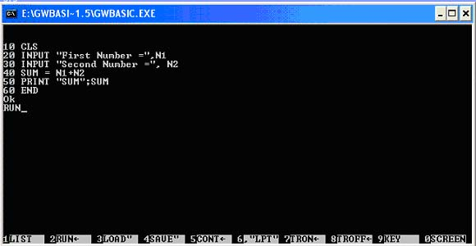](http://1.bp.blogspot.com/-hSk91OXFNiY/TyYxqyaFdCI/AAAAAAAAADw/IhX4iGYFxy0/s1600/p3+copy.jpg)

[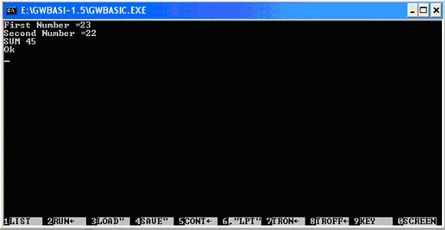](http://2.bp.blogspot.com/-wtjvWz44TuQ/TyYxxViXECI/AAAAAAAAAD4/FHVruqPgtTc/s1600/o3+copy.jpg)

**Algorithm**

Step 1  START

Step 2  INPUT   N1 ,N2   B=2

Step 3  COMPUTE     SUM N1+N2

Step 4  PRINT  SUM

Step 5 END

**Practical: 3: Write such program which can read six numbers and print their average**.

[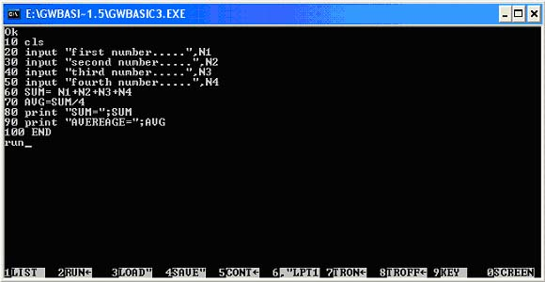](http://2.bp.blogspot.com/-8j3WjJ22mi4/TyYyLO62VJI/AAAAAAAAAEA/fm1GQYkeM0g/s1600/o5.jpg)

**Algorithm**

Step 1  START

Step 2  INPUT       N1, N2, N3, N4, N5, N6

Step 3  COMPUTE     AVG=( N1+N2+N3+N4+N5+N6) /6

Step 4  PRINT             AVG

Step 5  END

**Practical: 4: Write a program which can find the largest number of given three numbers.**

[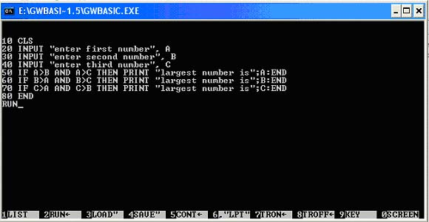](http://3.bp.blogspot.com/-aUBFOYmQ2QA/TyYy1DzyU1I/AAAAAAAAAEI/QiYHYZdrKwg/s1600/p4+copy.jpg)

[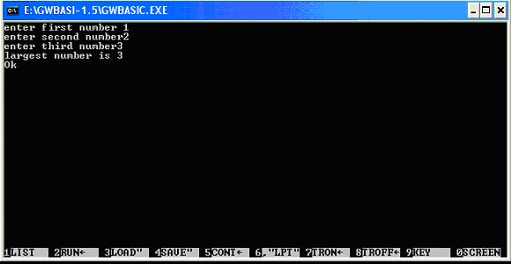](http://4.bp.blogspot.com/-Xth6jKgvHzk/TyYy6Wfi6PI/AAAAAAAAAEQ/m4hYaCZGQpw/s1600/o4+copy.jpg)

**Algorithm**

Step 1  START

Step 2  INPUT       N1, N2, N3

Step 3  DECISION  IS N1> N2 AND N1 > N3 IF YES THEN  PRINT  N1

Step 4  DECISION  IS N2> N1 AND N2 > N3 IF YES THEN  PRINT  N2

Step  5 ELSE PRINT  N3

Step 6  END

**Practical: 5: Write a program that can calculate the sum and average of four numbers.**

[](http://2.bp.blogspot.com/-6WBChpXFzfA/TyYzTYuk0lI/AAAAAAAAAEY/ubup-rRvB2w/s1600/o5.jpg)

**Algorithm**

Step 1  START

Step 2  INPUT       N1, N2, N3, N4

Step 3  COMPUTE     SUM= N1, N2, N3, N4

Step 4  COMPUTE   AVG= SUM/4

Step 5  PRINT  SUM,AVG

Step 6 END

**Practical: 6: Write a program that can draw a circle in a square.**

**Program:**

10    CLS

20     SCREEN 2

30      CIRCLE  ( 100,100), 50

40      LINE ( 168,35)- (472,165),,B

50      END

**Algorithm**

Step 1  START

Step 2  PRINT     SCREEN 2

Step

*3  PRINT      CIRCLE*

(100,100),50

Step 4  PRINT       LINE (168,35)- (472,165),,B

Step 5  END

**Practical: 7:** **Write a program that can calculate the area** **of a circle**.

[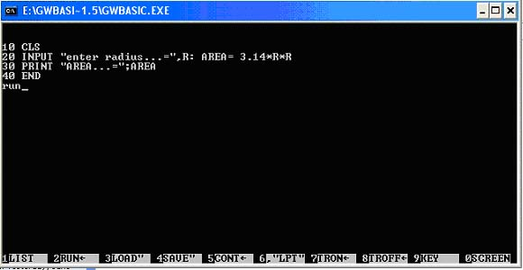](http://2.bp.blogspot.com/-GN8gR1hAKCE/TyYztCnxemI/AAAAAAAAAEg/-xZhKES9xqg/s1600/p7+copy.jpg)

[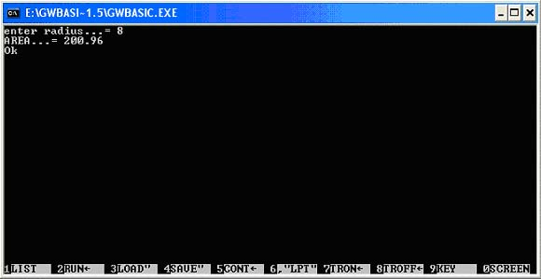](http://3.bp.blogspot.com/-qiDVPdz8J8w/TyYz5B1wGAI/AAAAAAAAAEo/a9c5R94hcUg/s1600/08+copy.jpg)

**Algorithm**

Step 1  START

Step 2  INPUT    N=R

Step 3  COMPUTE   AREA =3.14*R*R

Step 4  PRINT          AREA

Step 5  END

**Practical: 8: Write a program that can draw a circle.**

**Program:**

10    CLS

20     SCREEN 2

30      CIRCLE  ( 100,100), 50

40      END

**Algorithm**

Step 1  START

Step 2  PRINT     SCREEN 2

Step

*3  PRINT      CIRCLE*

(1000,100),50

Step 4  END

**Practical: 9: Write a program that can find the value of a solid cylinder**

[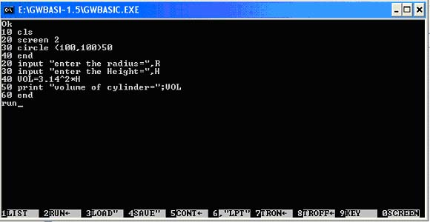](http://2.bp.blogspot.com/-HzMnrhsQ50I/TyY0XceI-hI/AAAAAAAAAEw/wFjoyyprHYI/s1600/p10+copy.jpg)

[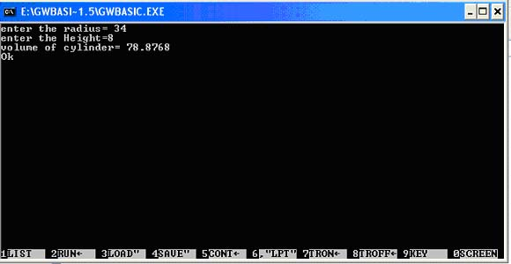](http://4.bp.blogspot.com/-bS3RxiqXbJI/TyY0f_yJwcI/AAAAAAAAAE4/G7Ujx4lkucg/s1600/o10+copy.jpg)

**Algorithm**

Step 1  START

Step 2  INPUT      R , H

Step 3  COMPUTE VOL= 3.14*R^2*H

Step 4    PRINT  VOL

Step 5  END

**Practical:10: Write a program that can calculate the area of a rectangle**

[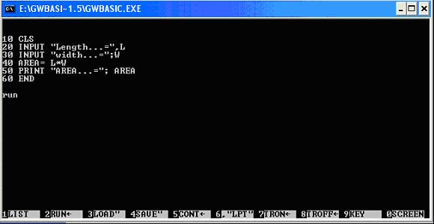](http://2.bp.blogspot.com/-PcKwudzbbL4/TyY0xjA-W9I/AAAAAAAAAFA/pItaluPxuyk/s1600/p11+copy.jpg)

[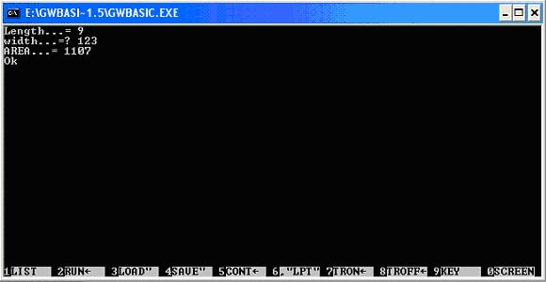](http://3.bp.blogspot.com/-cKiPRTjRWoo/TyY1WxorPMI/AAAAAAAAAFI/K-xZYZK_Jjk/s1600/o11+copy.jpg)

**Practical:11: Write a program to show 1st ten odd numbers using while wend loop.**

[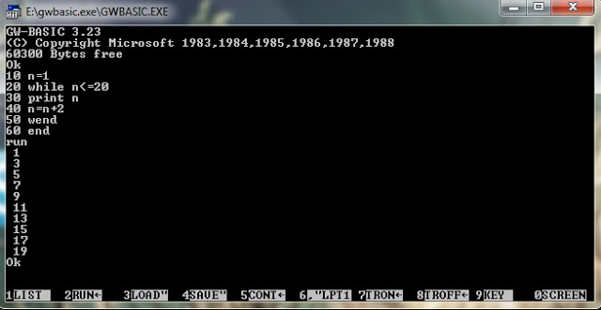](http://3.bp.blogspot.com/-On9fQEcXX1E/UE9keydOJbI/AAAAAAAAAMQ/gS67rc2POmI/s1600/Untitled.jpg)